

SCHOOL OF COMPUTING, ENGINEERING & INTELLIGENT SYSTEMS

COM326 OBJECT ORIENTED PROGRAMMING
TEAM ASSIGNMENT
COURSEWORK SUBMISSION COVER SHEET

This sheet must be completed in full by all team members and attached to the front of the assessment before submission.

Submitted work is subject to the following assessment policies:

1 Coursework must be submitted by dates as specified by the Course/Subject Committee.

2 Students may seek prior consent from the Course/Subject Director to submit coursework after the official deadline; such requests must be accompanied by a satisfactory explanation, and in the case of illness by a medical certificate.

3 Coursework submitted without consent after the deadline will not normally be accepted and will therefore receive a mark of zero.

I declare that this is all my own work. Any material I have referred to has been accurately referenced and any contribution of Artificial Intelligence technology has been fully acknowledged. I have read the University’s policy on academic misconduct and understand the different forms of academic misconduct. If it is shown that material has been falsified, plagiarised, or I have otherwise attempted to obtain an unfair advantage for myself or others, I understand that I may face sanctions in accordance with the policies and procedures of the University. A mark of zero may be awarded and the reason for that mark will be recorded on my file.

Student Name | Student Number | Student’s Signature | Date

Task 1. Class diagram
Objective: Your team will create a single class diagram that accurately represents the structure and relationships of the classes required for the Online shop application.

Note: you should identify in your class diagram must show as much information as possible, including classes, their properties and types with access levels (visibility), methods and constructors, their relationships with other classes, as well as super classes and subclasses (if any). When denoting class association, ensure lines are not crossing as this can confuse overall understanding of the class diagram.

Insert a clean and neat UML class diagram here showing the requirements listed above. You must use UML class diagram notation, and not other notation such as ER diagrams.

Sample class diagram is shown below. Please remove this sample diagram and guidance text (above) from your report and replace with your answer.
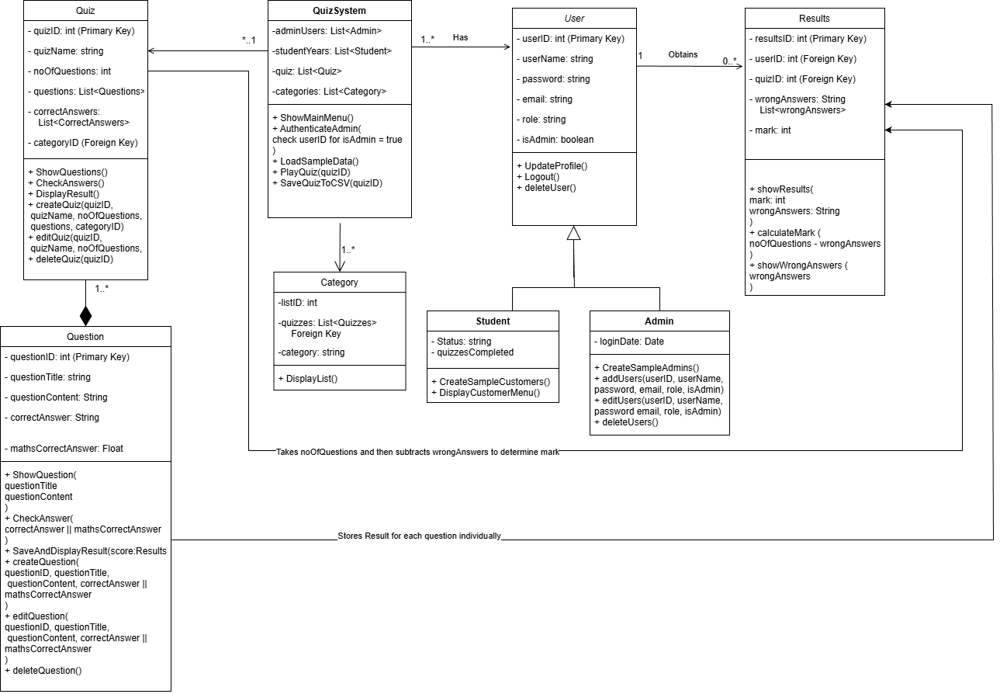

Class diagram important features
Your team must describe in detail all of the important features of your class diagram in this section. Important discussions include the classes and their properties, visibility, and methods. You must describe the logic behind your relationship decisions between each class as well as inheritance, association, aggregation, composition, multiplicity (if any).

The UML diagram above gives a clear overview of how our system works. The quiz system class, which basically runs the application it keeps private lists which are admins, students, quizzes and categories, it also uses public methods to handle things like logging in, loading data, showing menus, and running quizzes. The Quiz class stores key details like the quiz ID, name, number of questions and its list of question objects. It also includes methods to show questions, check answers, display results and manage quizzes. Each question stores its own information such as the question text and correct answer and also provides methods to present and validate the question. The Category class keeps track of category names and the quizzes that belong to them, while the results class records a user’s score, wrong answers. While the User class stores information like username, password, email and role and with methods for updating the profile and logging out and deleting users. From this base class, admin and student inherit common features but also include their own unique classes.

Please remove this guidance text (above) from your report and replace with your answer.

Please also ensure each team member has completed the WebPA peer assessment.

